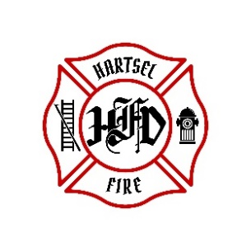
HARTSEL FIRE PROTECTION DISTRICT
BOARD MEETING AGENDA

October 13, 2023

- CALL TO ORDER:

- PLEDGE OF ALLEGANCE

- APPROVAL OF AGENDA:

- CITIZENS COMMENTS / GUEST SPEAKERS:

- APPROVAL OF MINUTES DATED: September 14, 2023

- BOARD CONCERNS / COMMENTS:

- FINANCIALS:
  - Accept Financials
  - Approve Bills
  - Approve Fund Transfers
  - Sign Documents / Checks

- CHIEF’S REPORT:
  - Calls to Date: 2022 ________, 2023 _______
  - Impact Fees to Date: 2022_______, 2023_______

- OLD BUSINESS:
  - Health Insurance CEBT
  - Chief Contract
  - Facility Equipment Report

- NEW BUSINESS:
  - Budget Presentation
  - Rig Financing Report from Treasurer

- ADJOURNMENT:

POSTED 10/10/2023 @ H.F.P.D. HEADQUARTERS, WEBSITE WWW.HARTSELFIRE.ORG

