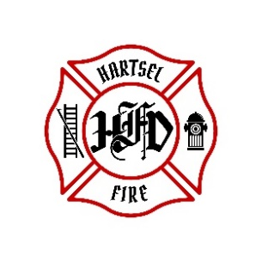
HARTSEL FIRE PROTECTION DISTRICT
BOARD MEETING AGENDA

January 5, 2024

- CALL TO ORDER:

- PLEDGE OF ALLEGIANCE

- APPROVAL OF AGENDA:

- CITIZENS COMMENTS / GUEST SPEAKERS:

- BOARD CONCERNS / COMMENTS:

- APPROVAL OF BUDGET

- ADJOURNMENT:

POSTED 1/2/2024 @ H.F.P.D. HEADQUARTERS, WEBSITE WWW.HARTSELFIRE.ORG

