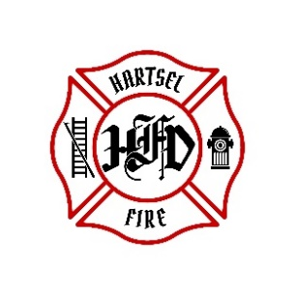

**HARTSEL FIRE PROTECTION DISTRICT**

**PENSION BOARD MEETING**

**October 10, 2025**

1. **CALL TO ORDER:**

**2. APPROVAL OF AGENDA:**

**3. APPROVAL OF PENSION MINUTES DATED: July 11, 2025**

**4. OLD BUSINESS:**

1. **2nd Quarter 2025 FPPA Allocation Report**

**5. NEW BUSINESS:**

**6. ADJOURNMENT:**

**POSTED 10/1/2025 @ H.F.P.D. HEADQUARTERS, WEBSITE** [**WWW.HARTSELFIRE.ORG**](http://WWW.HARTSELFIRE.ORG)