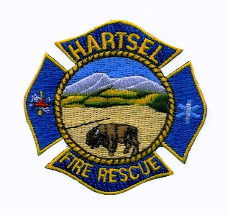
HARTSEL FIRE PROTECTION DISTRICT
BOARD MEETING
AGENDA

January 12, 2023
5:00 P.M.

- CALL TO ORDER:

- APPROVAL OF AGENDA:

- APPROVAL OF MINUTES DATED: December 15, 2022

- CITIZENS COMMENTS:

- BOARD CONCERNS / COMMENTS:

- OLD BUSINESS:
  - Theft at Station 4
  - Command Truck
  - Burn Facility
  - Accounting & Payroll
  - Facility Equipment Report

- NEW BUSINESS:
  - Extrication Equipment
  - Consolidation of Bank Accounts

- FINANCIALS:
  - Accept Financials
  - Approve Bills
  - Approve Fund Transfers
  - Sign Documents / Checks

- CHIEF’S REPORT:
  - Calls to Date: 2022 ________, 2023 _______
  - Impact Fees to Date: 2022_______, 2023_______

10. ADJOURNMENT:
POSTED 1/10/2023 @ H.F.P.D. HEADQUARTERS, WEBSITE WWW.HARTSELFIRE.ORG

