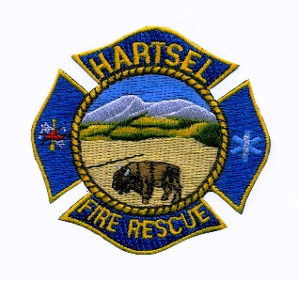
HARTSEL FIRE PROTECTION DISTRICT
BOARD MEETING AGENDA

June 8, 2023

- CALL TO ORDER:

- APPROVAL OF AGENDA:

- APPROVAL OF MINUTES DATED: May 11, 2023

- CITIZENS COMMENTS:

- BOARD CONCERNS / COMMENTS:

- OLD BUSINESS:
  - Policy and Procedures
  - Facility Equipment Report

- NEW BUSINESS:
  - Board Member Position
  - 2018 IFC Adoption
  - Salaries

- FINANCIALS:
  - Accept Financials
  - Approve Bills
  - Approve Fund Transfers
  - Sign Documents / Checks

- CHIEF’S REPORT:
  - Calls to Date: 2022 ________, 2023 _______
  - Impact Fees to Date: 2022_______, 2023_______

10. ADJOURNMENT:
POSTED 6/5/2023 @ H.F.P.D. HEADQUARTERS, WEBSITE WWW.HARTSELFIRE.ORG

