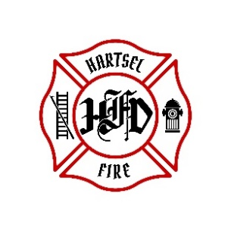
HARTSEL FIRE PROTECTION DISTRICT
BOARD MEETING AGENDA

December 15, 2023

- CALL TO ORDER:

- PLEDGE OF ALLEGANCE

- APPROVAL OF AGENDA:

- CITIZENS COMMENTS / GUEST SPEAKERS:

- APPROVAL OF MINUTES DATED: November 10, 2023

- BOARD CONCERNS / COMMENTS:

- FINANCIALS:
  - Accept Financials
  - Approve Bills
  - Approve Fund Transfers
  - Sign Documents / Checks

- FACILITY EQUIPMENT REPORT

- CHIEF’S REPORT:
  - Calls to Date: 2022 ________, 2023 _______
  - Impact Fees to Date: 2022_______, 2023_______

- OLD BUSINESS:
  - Chief Contract- still have not received any
  - Rosenbauer Engine
  - Type 3 Build

- NEW BUSINESS:

- ADJOURNMENT:

POSTED 12/12/2023 @ H.F.P.D. HEADQUARTERS, WEBSITE WWW.HARTSELFIRE.ORG

